**NETWORK DEPLIOYEMENT**

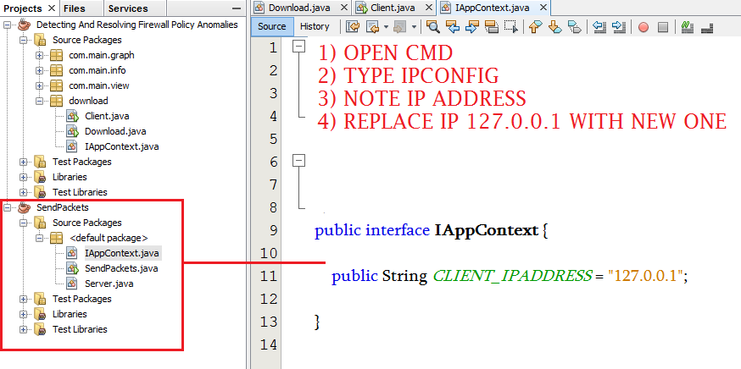

**SEND PACKET .JAVA FILE**

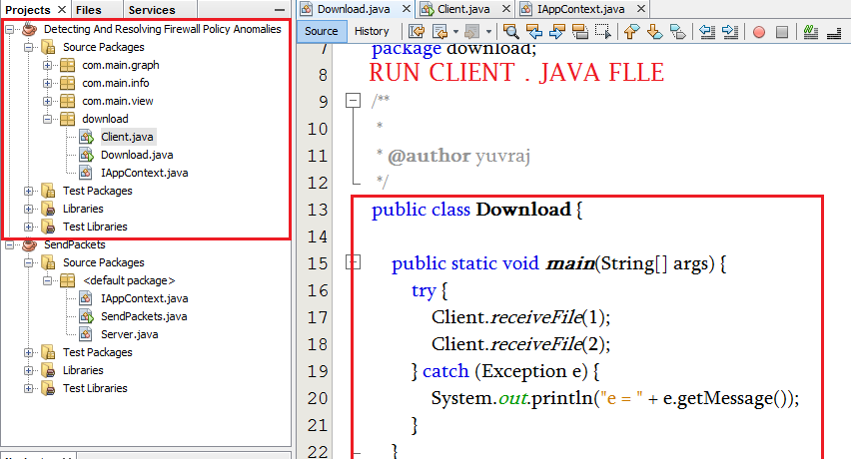

**RUN CLIENT . JAVA FILE**

